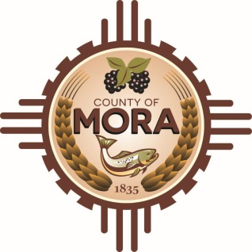

NOTICE OF POSSIBLE QUORUM
Mora Sheriff’s Office
1 Courthouse Drive
Mora, NM
Tuesday, January 9, 2024, at 9:00 a.m.

A potential quorum of the County Commission may attend a meeting with Singleton Schreiber to observe interviews involving HPPC Claims.

No decisions will be made, or public policy formulated, by the Commission members in attendance during the meeting.

Notices of this type are not subject to the Open Meetings Act and instead are issued as a courtesy to the public.

Published: 1/9/24 at 8:00 a.m.

