Mora County Veterans Memorial Committee

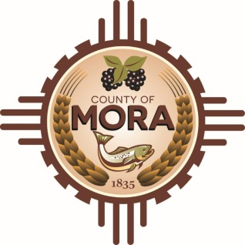
Joe Gene Pacheco Max Garcia
Chairman Treasurer

Harold Nolan Julian Olivas
Vice Chair Secretary

Veterans Memorial Committee
1 Courthouse Drive Mora, NM
November 14, 2023
1:00 p.m.
Agenda

- Call to Order
- Veterans Salute to the Flag of the United States of America
- Approval of Agenda
- Approval of Minutes
- October 10, 2023
- September 12, 2023
- Discussion/Action
- Update on Designation of County Roads A011 and El Oro Road
- Update on County Engineers/Architects on RFP
- Mora Creative Council (MCC) Fund Raising Report
- Veterans Day Activities Report
- Unfinished Business
- Outstanding/ Unresolved Old Business
- Pamphlets and Correspondence
- New Business
- Adjournment

If you are an individual with a disability who is need of a reader, amplifier, qualified sign language interpreter or any other form of auxiliary aid service to attend or participate in the meeting, please contact the Mora County Administration office located on Highway 518, 1 Courthouse Drive, Mora County Courthouse, Mora, New Mexico, as soon as possible at 575-387-5279.

Posted: Bulletin Board, County Website; -11/9/23

