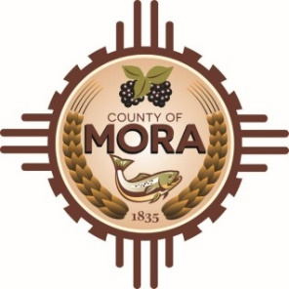

COUNTY OF MORA

Notice of Special Meeting
Board County Board of County Commission
Monday, October 30, 2023, at 5:00 p.m.
County Commission Chambers, 1 Courthouse Drive, Mora, NM 87732
The Mora County Board of County Commission will hold a Special Meeting on Monday, October 30, 2023, at 5:00 p.m. at the Mora County Administration Building, Commission Chambers, Mora, New Mexico. Agendas may be obtained at the County Manager’s Office in the afternoon on Friday, October 27, 2023 or at https://towncloud.oi/go/mora-county-nm.
_______________________
Join Zoom Meeting
https://us06web.zoom.us/j/83568237097
Meeting ID: 835 6823 7097

One tap mobile
+12532050468,,83568237097# US

If you experience difficulties connecting via Zoom, please call the County Manager’s Office at
575-387-5925.

Note: The Mora County Commission may convene in Executive Session to discuss personnel and litigation related matters, as permitted by Section 10-5-1 of New Mexico Open Meetings Act, NMSA 1978.
If you are an individual with a disability who is in need of a reader, amplifier, qualified sign language interpreter or any form of auxiliary aid service to attend or participate in the meeting, please contact the Mora County Administration office located at 1 Courthouse Drive, Mora, NM or call 575-387-5279.

Published: 10/27/2023

