Board of County Commission

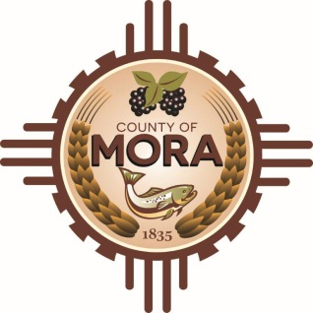
George Trujillo David M. Montoya
Commission Chair Interim County Manager

Johnny Trujillo
Commission Vice-Chair

Veronica Serna
Member

Mora County Board of County Commission
Special Meeting
Tuesday, June 27, 2023, at 4:30 p.m.
County Commission Chambers, 1 Courthouse Drive, Mora, NM 87732

Teams Meet
Click here to join the meeting
Meeting ID: 223 507 017 407
Passcode: uZomCC

The Mora County Board of Commission will hold a Special Board Meeting on Tuesday, June 27, 2023, at 4:30 p.m. at the Mora County Courthouse/Administration Building – Commission Chambers, Mora, New Mexico. Agendas may be obtained at the County Manager’s office on Friday, June 23, 2023, or at https://towncloud.io/go/mora-county-nm/.

The Mora County Commission may convene in Executive Session to discuss personnel matters, as permitted by section 10-15-1(H)(2) of the New Mexico Open Meeting Act, NMSA 1978 and matters subject to the Attorney Client privilege pertaining to threatened or pending litigation in which the County of Mora is or may become a participant, as permitted by Section 10-15-1 (H)(7) of the New Mexico Open Meetings Act, NMSA 1978.

If you are an individual with a disability who needs a reader, amplifier, qualified sign language interpreter or any other form of auxiliary aid service to attend or participate in the meeting, please contact the Mora County Administration office located on Highway 518; Mora County Courthouse, 1 Courthouse Drive, Mora, NM 87732; 575-387-5279.

PUBLISH: Bulletin Board; website; – 6/23/23

