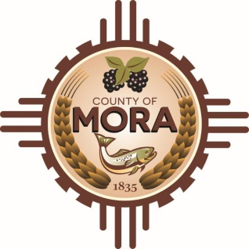***County Commissioners***

***George Trujillo David M. Montoya***

*Commission Chair Interim County Manager*

***Johnny Trujillo***

*Commission Vice-Chair*

***Veronica Serna***

*Member*

Board of County Commission Emergency Meeting

Microsoft Teams meeting

**Join on your computer, mobile app or room device**

[Click here to join the meeting](https://teams.microsoft.com/l/meetup-join/19%3ameeting_YmU5OWMzMTAtNjZlNi00ZjExLWJjY2QtMDg2Y2M0ZjQ5NGI0%40thread.v2/0?context=%7b%22Tid%22%3a%22a4739c36-aecc-4ff6-88f4-5a47b55b2a8c%22%2c%22Oid%22%3a%22c13a56ab-8923-43f2-8c8b-ca2e5175538a%22%7d)

Meeting ID: 232 076 155 23   
Passcode: 6MZsJx

AGENDA

1. Call to Order
2. Pledge of Allegiance and Salute to the Flag of the State of New Mexico
3. Roll Call
4. Approval of Agenda
5. Discussion: Emergency Procurement for Mora County Roads
6. Discussion/Action: Emergency Procurement for Mora County Roads – Resolution if necessary.
7. Executive Session:
8. Adjournment

*The Mora County Commission may convene in Executive Session to discuss personnel matters, as permitted by section 10-15-1(H)(2) of the New Mexico Open Meeting Act, NMSA 1978 and matters subject to the Attorney Client privilege pertaining to threatened or pending litigation in which the County of Mora is or may become a participant, as permitted by Section 10-15-1 (H)(7) of the New Mexico Open Meetings Act, NMSA 1978.*

*If you are an individual with a disability who needs a reader, amplifier, qualified sign language interpreter or any other form of auxiliary aid service to attend or participate in the meeting, please contact the Mora County Administration office located on Highway 518; Mora County Courthouse, 1 Courthouse Drive, Mora, NM 87732; 575-387-5279.*