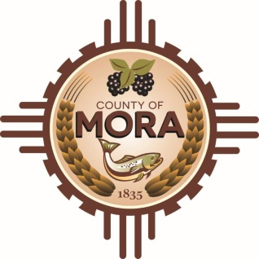
County Commissioners

Veronica M. Serna Michael Rivera
Commission Chair County Manager

Johnny Trujillo
Commission Vice-Chair

Frank L. Maestas
Member

Mora County Commission seeking 5 members for the Lodger’s Tax Committee
DUTIES AND RESPONSIBILITIES OF THE LODGER’S COMMITTEE,
The Chair of the County Commission shall appoint a five member Committee that consists of two members who are owners and operators or operators of lodgings subject to the occupancy tax within the county, two members who are owners or operators of industries located within the unincorporated area of the County that primarily provide services or products to Tourists, and one member who is a resident of the unincorporated area of the County the general public, in compliance with 3-38-22 NMA 1978. The Committee shall serve at the pleasure of the County Commission and shall advise the County on the expenditure of funds authorized by section 4 of the ordinance for advertising, publicizing and promoting tourist attractions and facilities in the County. The committee shall submit to the County Commission recommendations for the expenditure of funds authorized pursuant to the Lodger’s Tax Act for advertising, publicizing and promoting tourist related attractions, facilities, and events in the County
RULES GOVERNING THE OPERATION OF THE COMMITTEE
- Not withstanding the terms established in subsection 2 of the ordinance hereof or any provisions of law, any person serving on the committee may be removed by majority vote of the County Commission. Vacancies shall be filled by the Chair of the County Commission. A person appointed to fill a vacancy shall serve the remainder of the term to which he is appointed.
- The Committee shall annually, at the first regularly scheduled monthly meeting of the calendar year, elect the following officers:
- Chair
- Vice-Chair

The committee shall meet monthly at a date and time established by the County Commission. The meeting shall be conducted in compliance with the provisions 10-15-1, NMSA 1978. A member of the committee shall take minutes of each meeting, whether regular or special. Within (10) days of any meeting, the member shall forward a copy of the minutes to the County Manager.

Any party interested in being on the Committee must submit a letter of interest and or resume to the Planning and Zoning Director Brad Sena. Letters can be sent to bsena@countyofmora.com or PO Box 580 Mora NM 87732. The deadline March 11, 2022 . If there are any further questions please contact Brad Sena at 575-387-5393.

